Model Manager Converter Fatal Errors
  - Resolution Guide
QG = Quality Gate
Model Manager Review Folder: E:\Eterra\Distribution\sce\ToolsWorkspace\ModelManagerFolders\Review
Use for expanded logs for the station.

Missing Transformer Model
SSG Name:
Error Log Entry Example:

Missing Line Conductor Model
SSG Name: ALOLA_AUTO_20615.SSG
Error Log Entry Example:
-F-,FWF266,PH382E$4115222E,Line conductor model was not found in global data.,Record name: Line Field name: CondModA,Station External Device: PH382E$4115222E,OH_653_A_2PH_653_A_N_2.4KV,,,,ALOLA,,PH382E$4115222E,ENG

Issue:
This error indicates that there is a missing Line Conductor Model Definition in the global.csv file (E:\Eterra\Distribution\sce\ToolsWorkspace\ModelManagerFolders\Processing\global.csv)
Resolution Steps:
- In this example you would search the global CSV file for the name of the conductor minus the voltage,“OH_653_A_2PH_653_A_N_”
- Copy a similar record with a voltage level close to this one.
- IMPORTANT: make sure to change the 3rd value which is the unique identifier by adding “a” or another letter to the end of the id. The best practice for this is to paste the new record directly beneath the copied record so its easier to keep track of the unique ids
- Reprocess the job that had a fatal (in this case, ALOLA_AUTO_20615.SSG)
  - Right click Reprocess Substation Group(s) from Processing
  - Right click Unblock Substation Groups(s) OR uncheck ‘Blocked’
Resolution Steps:

Missing Switch Model

Unmapped Point
SSG Name: SHANDIN_AUTO_20630.SSG
Error Log Entry Example:

-F-,FWF172,ED020E38-747A-4DEC-A4F5-F3EF99CD2C20,Device not mapped to meas point.,Record name: Analog Field name: Device Name: F18454Y:RFI19811_IA CID: SHANDIN.FI.RFI19811.IA Devtyp: Fault_Detector Device: F18454Y:RFI19811 Station Internal Measurement Device: ED020E38-747A-4DEC-A4F5-F3EF99CD2C20,Station Internal Device: ED020E38-747A-4DEC-A4F5-F3EF99CD2C20,,,,,,,,GIS

run SIFB by running the UpdateSubStations.ps1 script located in E:\Eterra\Distribution\sce\ToolsWorkspace\ScriptSSG with the stations.txt file containing the name of the station.
Right click on the failed/blocked station record in the Model Manager Substation Group Files Summary and reprocess/unblock the record.

Broken Topology
SSG Name:
Error Log Entry Example:

QG Missing Internal Source
SSG Name:
Error Log Entry Example:

QG Floating Feederhead
SSG Name:
Error Log Entry Example:

QG: Missing Interface
SSG Name: IRON MT SCE.ISSG
Error Log Entry Example:
-F-,QGR911,,Gate evaluation result: FAIL(1 out of 5 rules failed), Gate ID: 1, Gate Name: TEMP GATE - Do Not Push,,,,,,,,ENG
Expanded Debugging:
You will need to get more details on what rule failed in the quality gate. Open the individual {station name}.log file located here: E:\Eterra\Distribution\sce\ToolsWorkspace\ModelManagerFolders\Review
Find the fatal entry “-F-,QGR911,,Gate evaluation result: FAIL(1 out of 5 rules failed), Gate ID: 1, Gate Name: TEMP GATE - Do Not Push,,,,,,,,ENG”. This will have a sub item to the effect of “Rule evaluation result: FAIL, Rule ID: 10, Rule Name: Missing Interface, RuleDefinition: MustNotContain MoreThan 0 NTP168 message(s), Actual Message Count {number}.
Open Substation Editor – The shortcut is located in C:\ProgramData\Microsoft\Windows\Start Menu\Programs\Eterra\Distribution\Tools\Modeling Tools\
File > Open
Interfaces look like the generation symbol shown below – the error we are debugging indicates that there are missing interfaces.
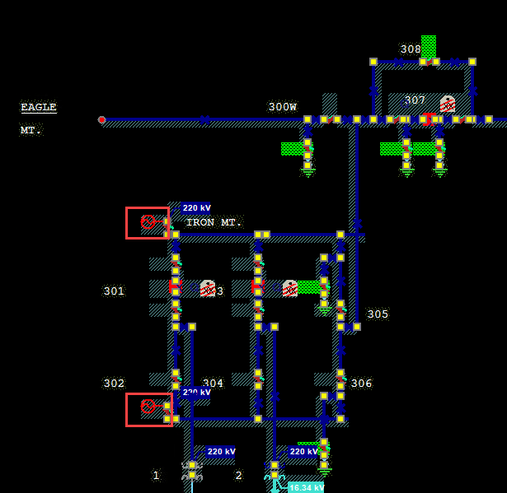
At this point, youll need to run SIFB by running the UpdateSubStations.ps1 script located in E:\Eterra\Distribution\sce\ToolsWorkspace\ScriptSSG with the stations.txt file containing the name of the station.
Right click on the failed/blocked station record in the Model Manager Substation Group Files Summary

Model Issue?

Questions
- What is “ST github” – found in runbook
- When receiving “Hello, WR577782 was rejected by MM” in GESW --> Model Manager --> ADMS (Group Chat for tracking work request issues), how do I look this work request up?
- Regarding the resolution to the “missing conductor model”, is the workflow the same for “missing transformer model” and “missing switch model”?

